**Task Description#1**

* Zero-shot: Prompt AI to write a function that checks whether a given year is a leap year.

ANS: IN GOOGLE COLLAB ITS DIRCTLY GIVING WITH EXAMPLE OUTPUTS

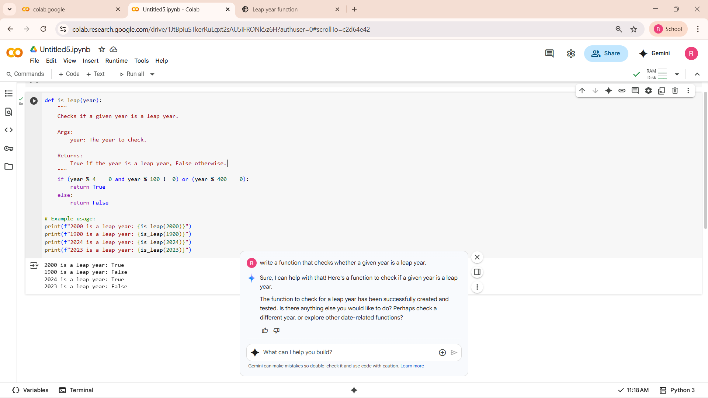

IN CHATGPT ITS GIVING THE CODE AS WELL AS EXAMPLE OUTPUT USAGE.

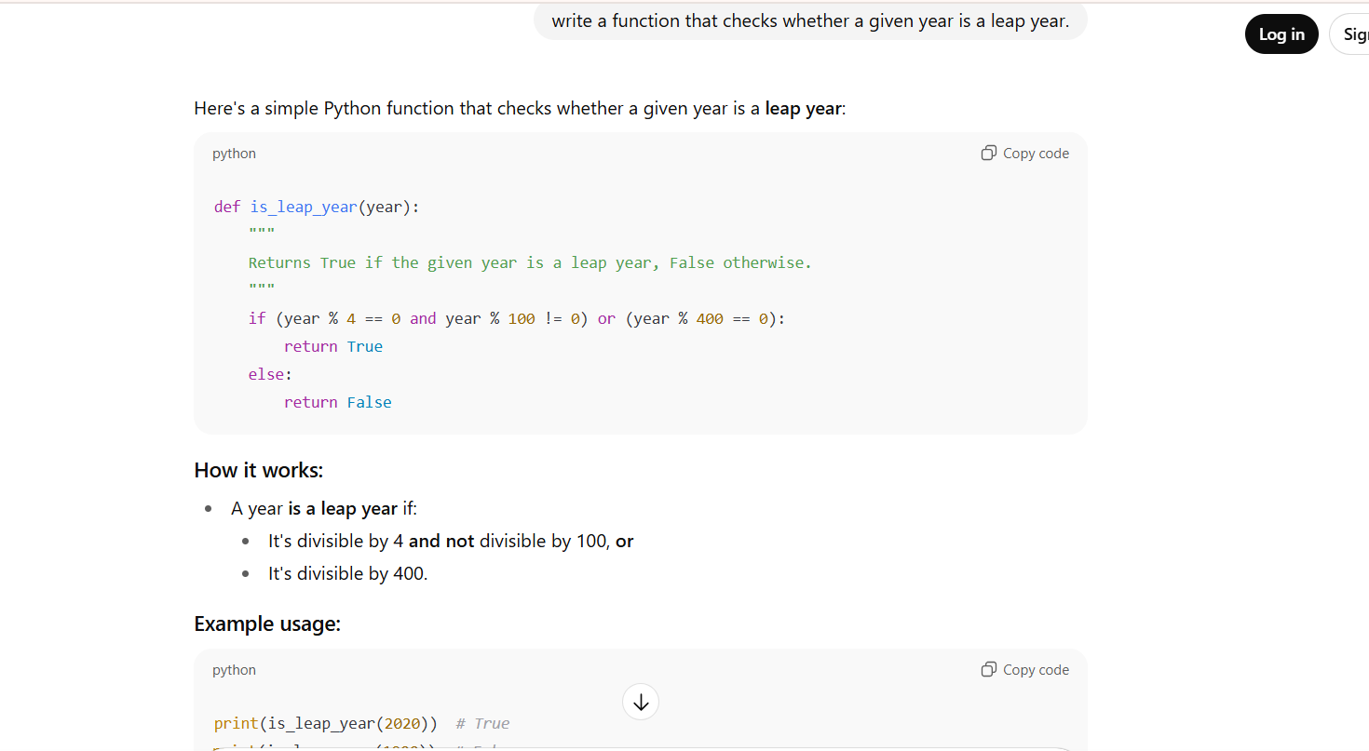

**Task Description#2**

* One-shot: Give one input-output example to guide AI in writing a function that converts centimeters to inches.

ANS: IF WE USED ONE SHOT PROMPTING ITS GIVING THE CORRECT

CONVERSION LOGIC . IN A SHORT FORM OF CODE.

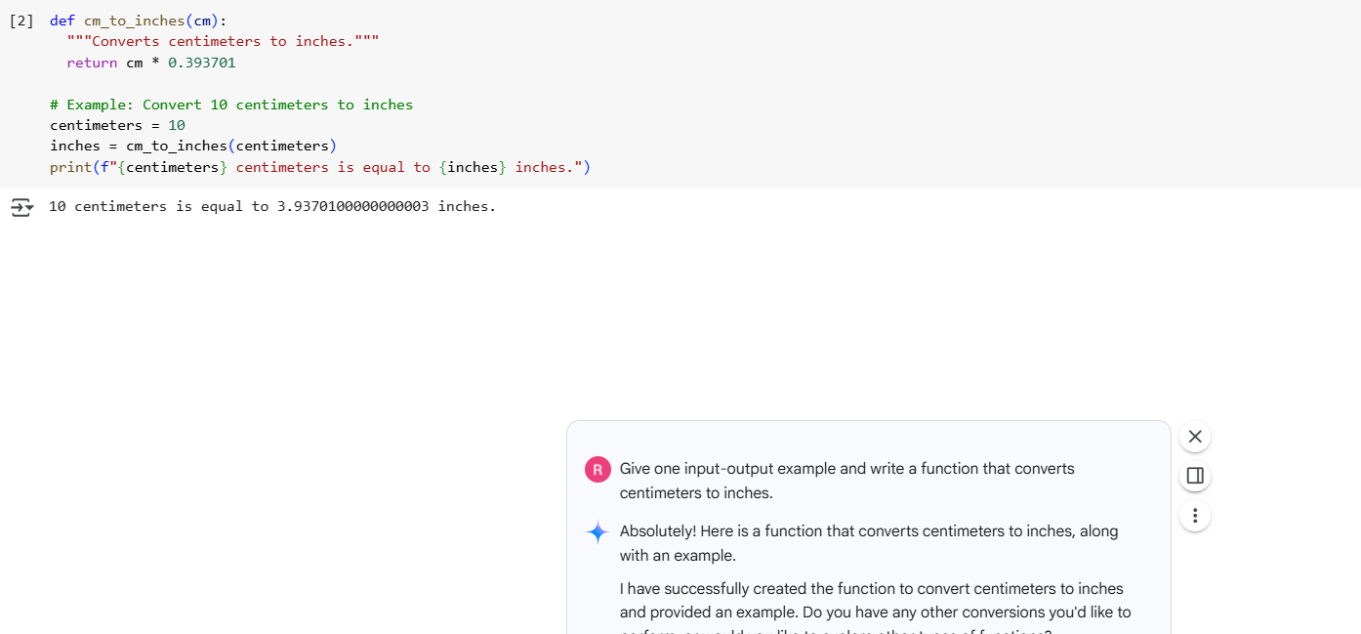

**Task Description#3**

* Few-shot: Provide 2–3 examples to generate a function that formats full names as “Last, First”.

ANS: IF WE ENTERED SINGLE NAME ITS SHOWING NONE BECAUSE SPILIT IS IN THE CODE. AND SPLIT MEANS DIVIDING FIRST NAME AND LAST NAME.

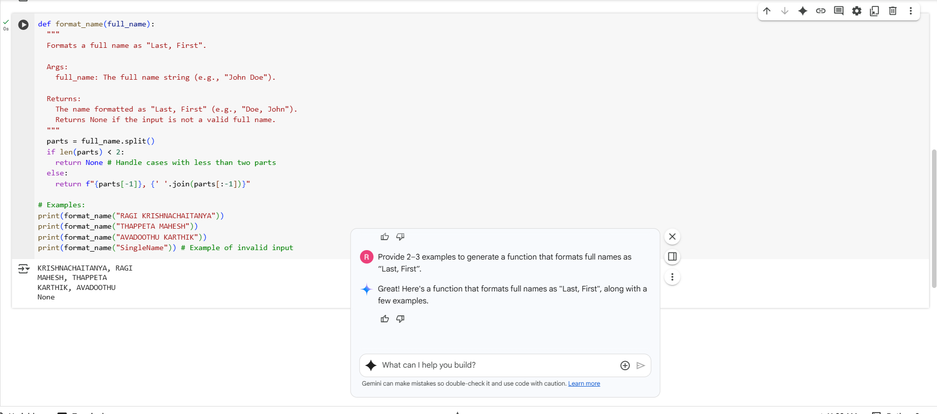

**Task Description#4**

* Compare zero-shot and few-shot prompts for writing a function that counts the number of vowels in a string.

AND: ZERO SHOT PROMPTING,IN THIS PROMPTING ITS NOT GIVING THE EXAMPLE OUTPUT..

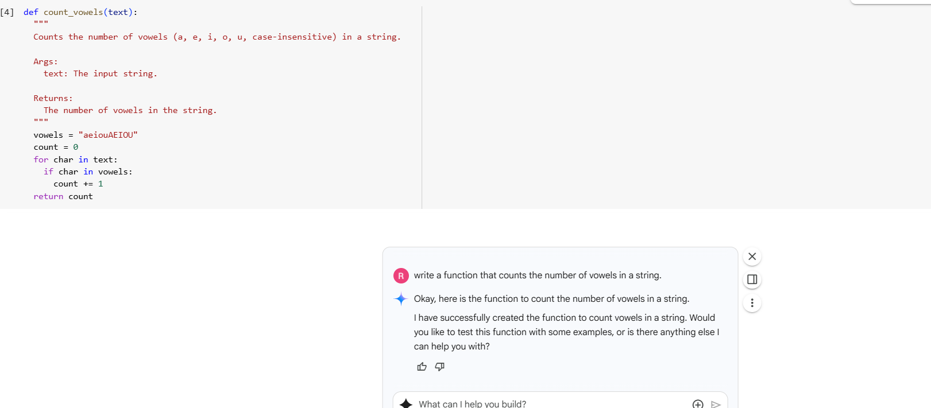

FEW SHOT PROMPTING: IF WE USED FEW SHOT PROMPTING IT IS GIVING INPUT OPTION AS WELL AS GIVING OUTPUT FOR THE INPUT..

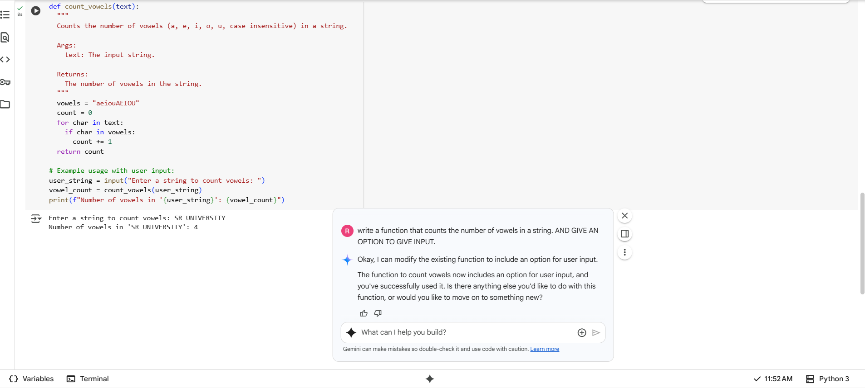

**Task Description#5**

* Use few-shot prompting to generate a function that reads a .txt file and returns the number of lines.

ANS: FEW SHOT PROMPTING :- AFTER GIVING FEW SHOTS PROMPTS IT HAS DIRECTLY CREATEDD A DUMMY FILE WITHIN THE NOTEBOOK(GOOGLE COLLAB).

